4-Bit breadboard computer

Design and Implementation of a discrete Logic-Based 4bit CPU

Designed and built by : Ezra Kyende (Tronic Zenergy)

Platform:
Breadboard Implementation using TTL/CMOS Logic ICs

2025

INTRODUCTION

My name is Ezra, and this is one of many projects I have worked on. Before starting this 4-bit computer, I had already been learning fundamental computer concepts such as bus communication, ALU operations, and data movement between registers. This provided insight into how real CPUs are built and motivated the development of this project.
I believe that a deeper understanding of technology comes from learning the basics first and gradually building knowledge and skill. Although computers continue to evolve rapidly, understanding what happens inside these systems remains essential.
This project was implemented as a 4-bit computer built entirely on breadboards using discrete logic ICs. The goal was to understand CPU operation at the hardware level, including registers, data buses, and arithmetic logic operations, without the use of microcontrollers or software-based control.

SYSTEM OVERVIEW

The 4-bit computer is a discrete logic–based system implemented entirely on breadboards. It follows a simple register-based architecture in which data is transferred through a shared 4-bit data bus, and processed by a central arithmetic logic unit (ALU).There is also a 4-bit bus that carries the instructions(select codes to ALU) and other operations
The system is controlled by a clock signal that synchronizes data movement and operations across all modules. Control signals determine when registers load data, when devices place data onto the bus, and which operation the ALU performs(either arithmetic or logic operations)
The computer is designed for educational and experimental purposes, focusing on clarity of operation rather than performance or instruction density.

Main Functional Blocks

- RAM & ROM – Holds the data and instructions
- 4-Bit Data Bus – shared comunication path for Data
- Registers – Store operands, instructions, and output data
- Arithmetic Logic Unit (ALU) – Performs arithmetic and logic operations
- Control Logic – Generates control signals for data flow and execution
- Input Interface – Manual data and instruction entry
- Output Interface – LED-based visualization of results and bus states
(7-segment display)

BLOCK & VISUAL DIAGRAM REPRESENTATION
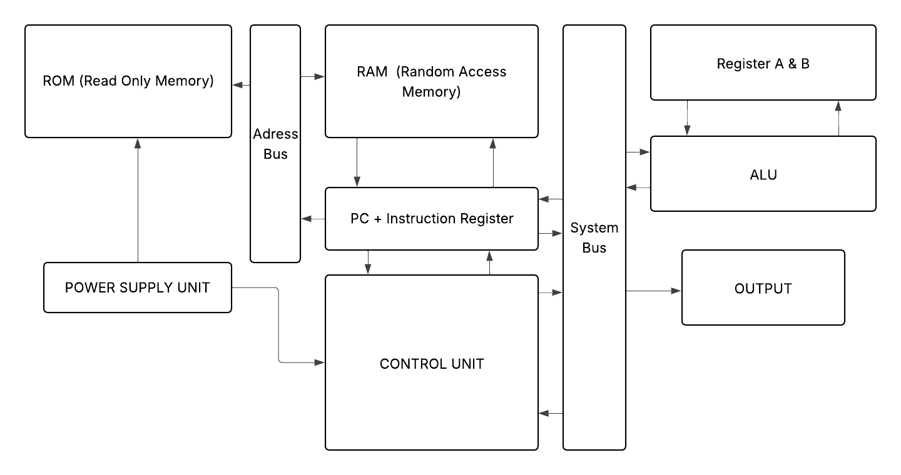
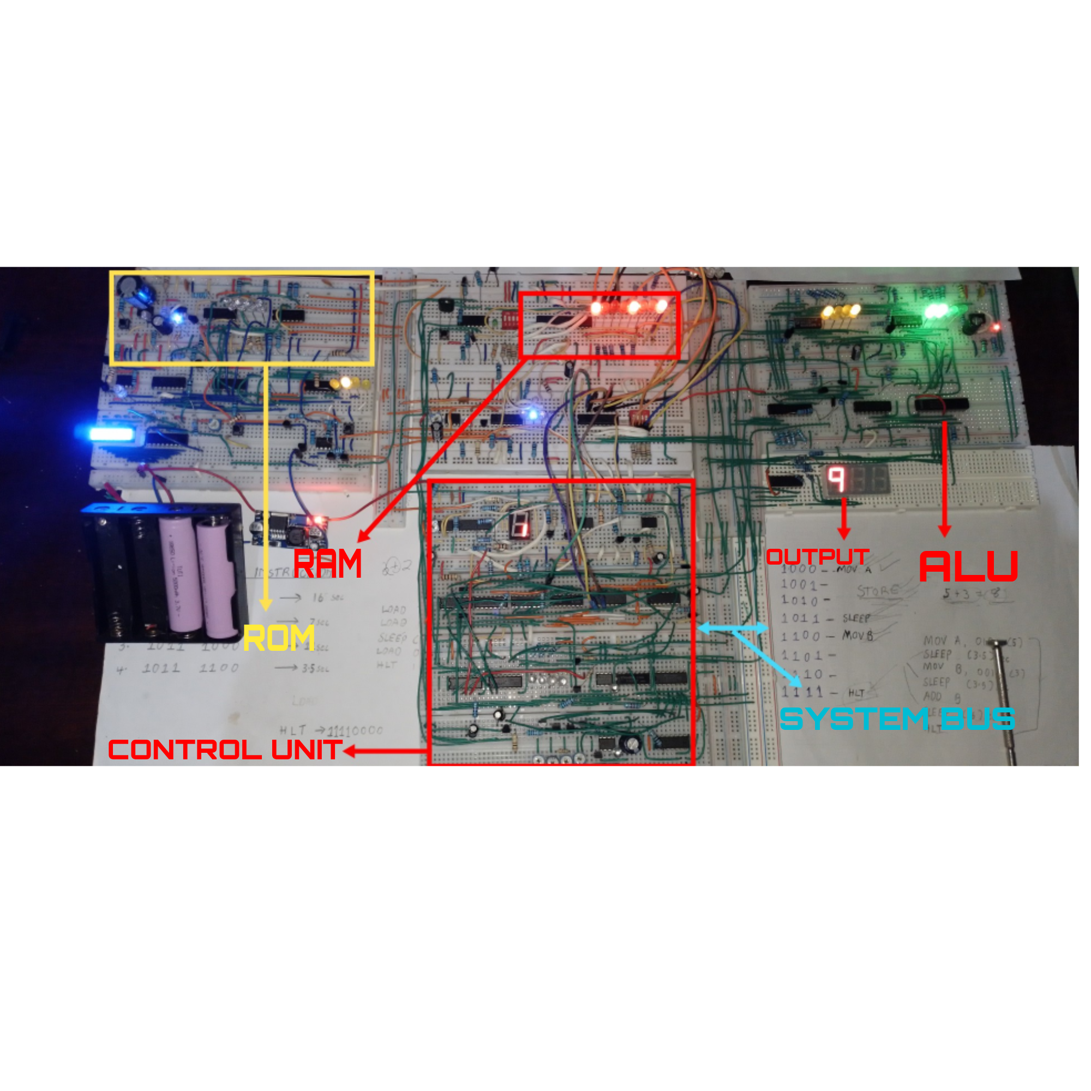

CORE ARCHITECTURE

- ROM
At first I decided to use M6294-04 ROM chip but later removed it after realizing its a masked ROM. Since the AT28c series rom chips are not easy to find I decided to use logic gates and counters to make a simple rom that carries the start up sequence of the 4-bit computer. The sequence involved system checks on different units: (control unit, ALU and others) also resetting all registers and the program counter.
- RAM
The chip that I went for here is a D436CX-15L Static RAM. The chip has 8,192 memory locations but I used only 15 of them since I was making a 4bit computer. Later when ill be designing an 8-bit computer I will use more memory locations. Its function was to carry the program to be executed by the computer, whereby the program counter was used to address different memory locations inside the RAM to fetch the instructions. It has great features and is easy to program.
- POWER SUPPLY UNIT
I used 2 - 3.7v, 5000 mAh Li-ion batteries as the power supply. From the batteries I used L2596 buck converter and adjusted it to give a constant 5v to the computer. On the power rails of the breadboards of different units I used 0.1uf, 100uf, 10uf, and 1uf capacitors to reduce noise and increase stability of the system.
I also added a blue LED bar 10 segment display driven by Lm3914 to display the battery level in real time.
- ADDRESS BUS
The address bus was used to carry the address of the next instruction from RAM and ROM
- PC + INSTRUCTION REGISTER
For the Program counter (PC) I used CD4029 4 bit binary counter. Its function was to give the address to the RAM and ROM of the next instruction to be executed. The IC has Jam inputs whereby one can preset the counter at any state asynchronously with the clock. This feature enables one to perform Loops and jumps.
For the instruction register I used 74HC373 IC, which is a high speed, 8-bit, D-type transparent latch. I used it to store both the opcode and operand from the RAM at a single fetch by the PC
- CONTROL UNIT
Since I didn’t have a ROM on the 4-bit computer I had a hard task at the control unit to design it to give all the necessary control signals needed to execute various tasks. This meant having many logic gates, timing circuits, decoders and encoders.
The control unit did many operations like giving the select codes for the ALU, control signals for register A & B and control when the PC could fetch the next instruction from the RAM.
- SYSTEM BUS
This is the communications path for the opcode and operand 8bit wide( 4-bit for the opcode, 4-bit for the operand).
- REGISTERS A & B
These are the temporary storage units for the data being manipulated. I used 2 – 74HC173 4-bit parallel load registers with great input and output controls
- ALU (Arithmetic and Logic Unit)
Here I used the 74LS181 4bit ALU which has many arithmetic operations like addition subtraction and logic operations eg AND, OR, NOT etc
- OUTPUT
For the output I used a common cathode 7-segment display and drove it with a CD4511 (BCD – 7segment ) driver. This was connected directly from the data bus.

CHALLENGES
- ROM – Without a ROM chip on the computer I had to wire how each and every instruction would be handled by the 4bit computer. This meant lots of logic gates, decoders and encoders needed to process the instruction and execute it at the control unit. This brought about power instabilities, messy wiring and a lot of debugging.
- DATA TRANSFER – The registers A and B could not share data between each other this meant instructions like MOV A, B could not be performed. This was caused by the fact that the outputs of the registers were not connected to the inputs
Each register also needed its own bus transceiver that makes it easy to write or to read data from it.
- ALU – The ALU needed a temporary storage register constantly saving ALUs answers. Here I used a shift register which proved very difficult since it lost data if there was an error clock signal or the answer (from the ALU) shifts quickly. There was also a need for a NOR gate logic constantly checking the output of the ALU to create a zero flag since the chip alone could give an overflow flag and a carry flag.
- MAR – A memory address register function is to sit between the RAM and the sources of the address. Addresses can come from the program counter, the instruction itself or from the programmer circuit during programming the RAM. Without the MAR the Program counter multi tasked to do all of this operations by itself, this was difficult to wire and to manage.
- BUS TRANSCEIVER – This is a chip that controls which device can talk to the system bus. I only used one at the ALU and registers side, for other units like RAM and the instruction register I had to handle them carefully to ensure that there is no conflict at the system bus. This meant careful timing controls to know who and at what time do they talk to the Bus
- OUTPUT – On the output I used a BCD to 7 segment display driver to drive a common cathode 7 segment display. The driver was not a hexadecimal driver meaning the display went blank from numbers 10-15
- BREADBOARD NOISE – The breadboard had a lot of noise which caused errors during programming the RAM, during instruction execution and other operations. To handle the noise I added decoupling capacitors on each breadboard used

INSTRUCTION SET (MACHINE CODE) OF THE 4BIT COMPUTER
1. 1000 – MOV A
2. 1100 – MOV B
3. 1001 – STORE (STR) A
4. 1010 – STORE (STR) B
5. 1111 – HALT (HLT)
6. 10110000 – SLEEP (16s)
7. 10110100 – SLEEP (7s)
8. 10111000 – SLEEP (11s)
9. 10111100 – SLEEP (3.5s)
10. 0100 – ADD
11. 0001 – A + B (OR)
12. 0111 – NOT A
13. 0110 – AB (AND)
14. 0011 – SUBTRACTION
15. 1101 – JO (Jump if Overflow)

